**SUPERSTORE DATA INSIGHTS AND QUESTION RESPONSES:**

**Questions:**

1. Which product categories have the highest total sales in the "Superstore" dataset?

Answer:

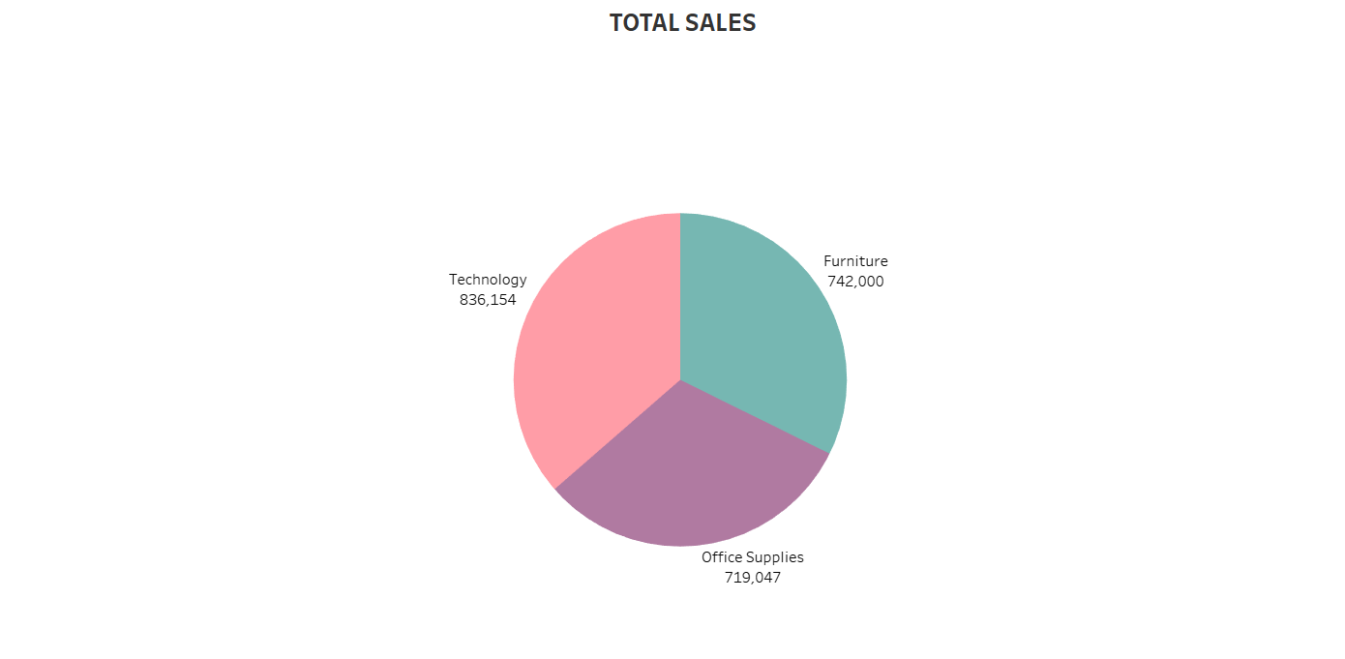

“TECHNOLOGY” category has the highest total sales in this "Superstore" dataset, following by “Furniture” and “Office supplies”.

This pie chart shows the distribution of sales in three categories over a period of time

1. How do the monthly sales amounts change over the course of a year?

Answer:

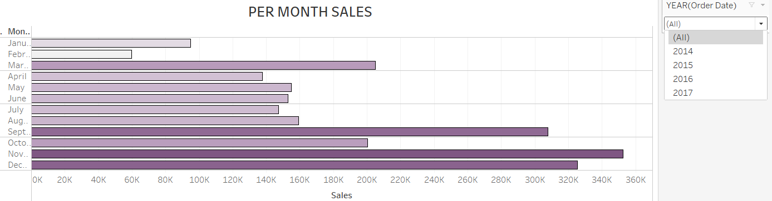

Based on the above chart we can see that the average monthly sales of the products based on all year is highest during October.

|  |  |  |
| --- | --- | --- |
| YEAR | MONTH | HIGHEST SALE |
| 2014 | September | 81777 |
| 2015 | November | 75973 |
| 2016 | December | 96999 |
| 2017 | November | 118448 |

1. How is the total sales amount distributed among different product categories?

Answer:



On the basis of this given Pie chart, we can easily visualize the distribution of total sales for each category:

|  |  |
| --- | --- |
| CATEGORY | TOTAL SALES |
| Technology | 836154 |
| Furniture | 742000 |
| Office Supplies | 719047 |

1. Can we analyse the sales performance of individual customers over time?

Answer:

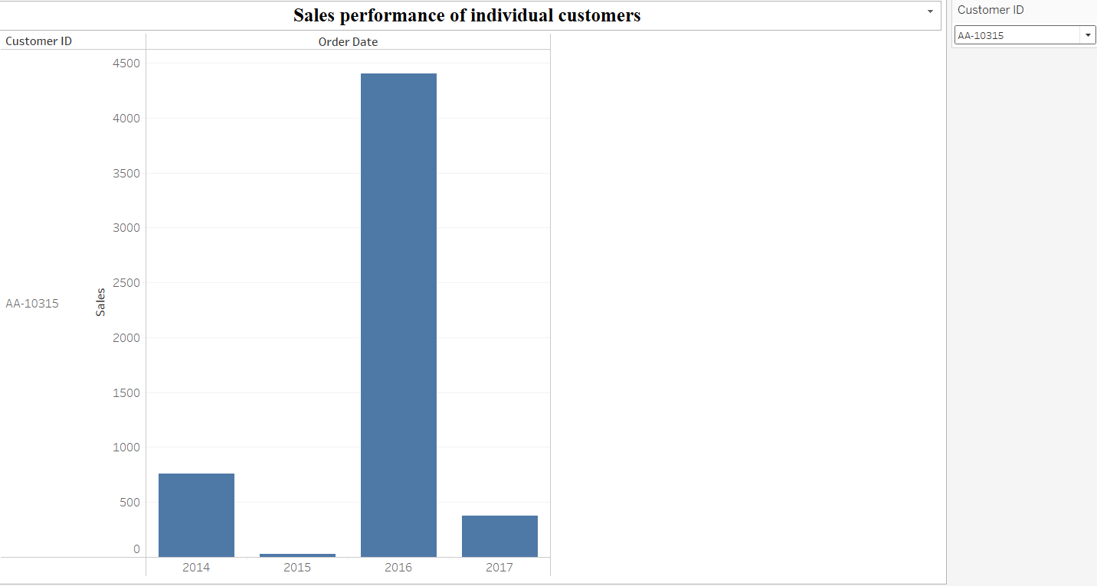

Yes, by adding filter based on the customer Id and analysing sales over time in visual

we can analyse the sales performance of individual customers over time. For making visual keen and user friendly we can edit filter by shaping it to (single value dropdown).

1. How do sales vary based on different days of the week and product categories?

Answer: 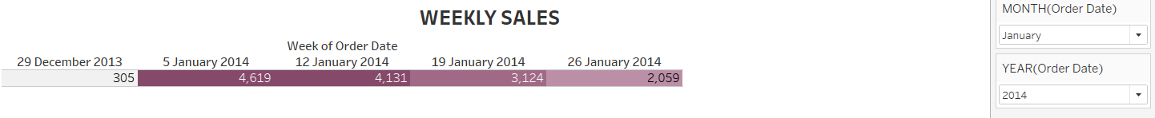

1. Can we visualise the sales growth of different product categories over time?

Answer: 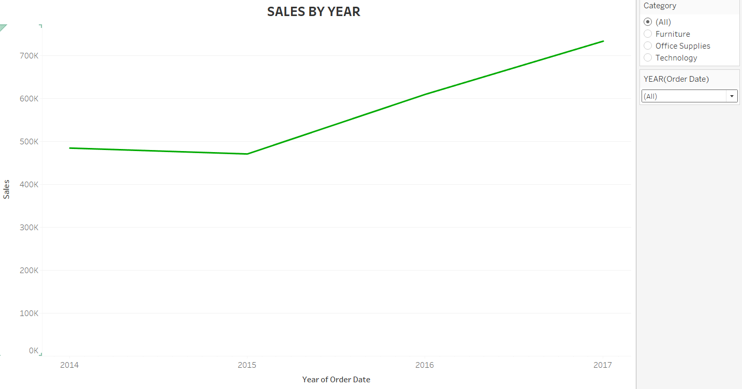

* This line chart shows the trend of sales over a time period.
* Through the category filter we can visualize the sales of particular category over a time
* The Year filter can help to visualize the sales over a particular year of a category.

1. How does the sales distribution vary across different regions in the "Superstore" dataset?

Answer:

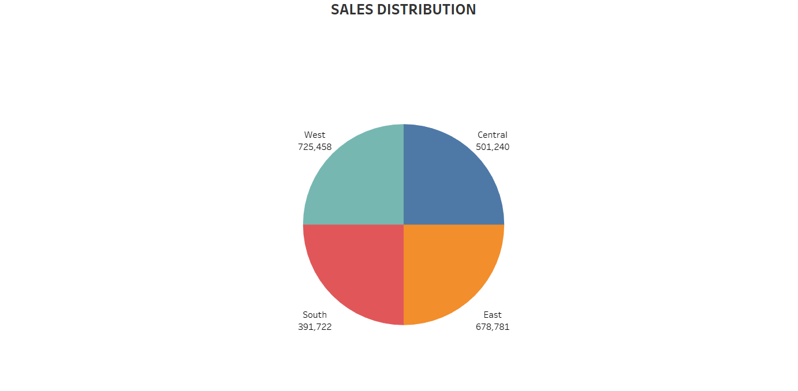

This graph shows the distribution of total sales over different region:

|  |  |
| --- | --- |
| REGION | SALES |
| East | 678,781 |
| West | 725,458 |
| Central | 501,240 |
| South | 391,722 |

8.Can we visualise the profit margins associated with different shipping modes and customer segments?

Answer:

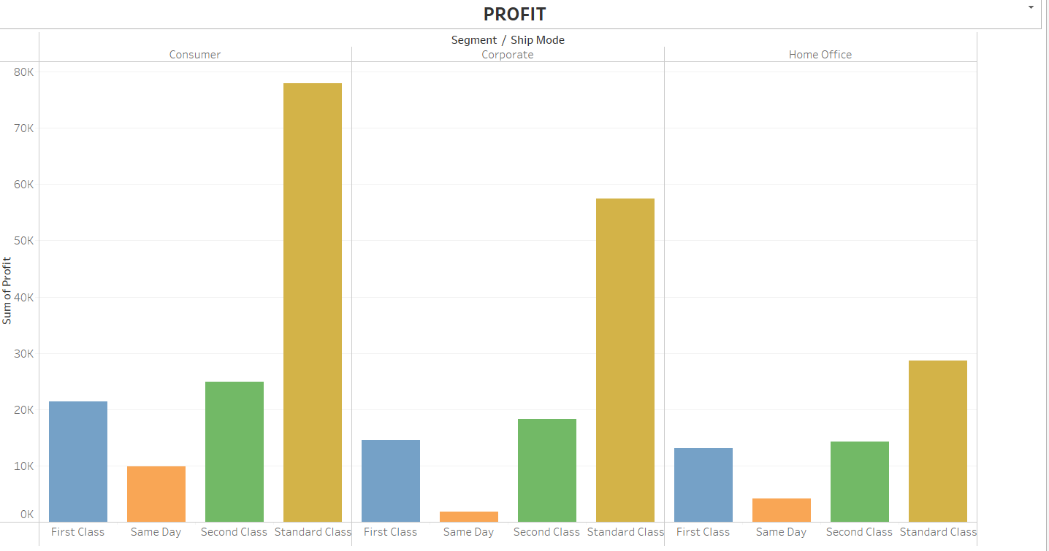

After visualising the graph, we can easily bring out insights that STANDARD CLASS of CONSUMER segment had brought out the highest profit [**77,924**] from the entire segment classes.

Standard class has been the leading profitable field in every segment while the Same day is being less productive and less profitable.

|  |  |  |
| --- | --- | --- |
| SHIP MODE | HIGHEST | LOWEST |
| FIRST CLASS | CONSUMER **[21,374]** | HOME OFFICE **[13,131]** |
| SAME DAY | CONSUMER **[9,874]** | CORPORATE **[1,818]** |
| SECOND CLASS | CONSUMER **[24,947]** | HOME OFFICE **[24,274]** |
| STANDARD CLASS | CONSUMER **[77,924]** | HOME OFFICE **[28,694]** |

1. What is the percentage contribution of each region to the overall sales?

Answer:

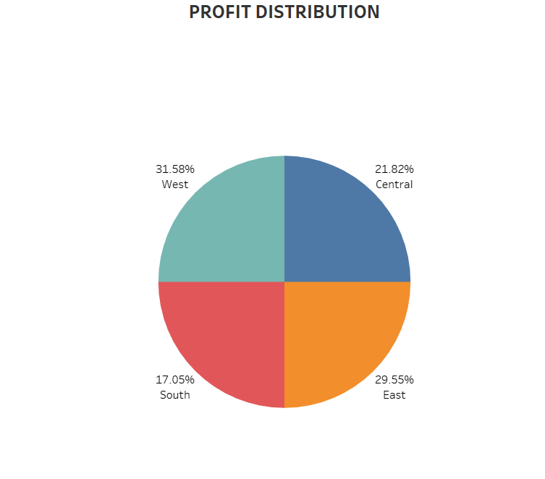

The above graph denotes that:

* WEST region has been contributing 31.58% of the overall sale [Highest]
* CENTRAL region has been contributing 21.82% of the overall sale [Highest]
* EAST region has been contributing 29.55% of the overall sale [Highest]
* SOUTH region has been contributing 17.05% of the overall sale [Lowest]

1. How long does it take to process orders for different product categories?
2. How do discounts affect overall profit?

Answer:



The Total Sum of Profit is: 28,6397

The Total Sum of Discount is: 1,561

The Total Sum of Discount is 0.545047 % of Total Sum of Profit. So, this does not create a big affect in profitability of business.

1. Can we visualise the relationship between product sales and profitability for different product categories?

Answer:

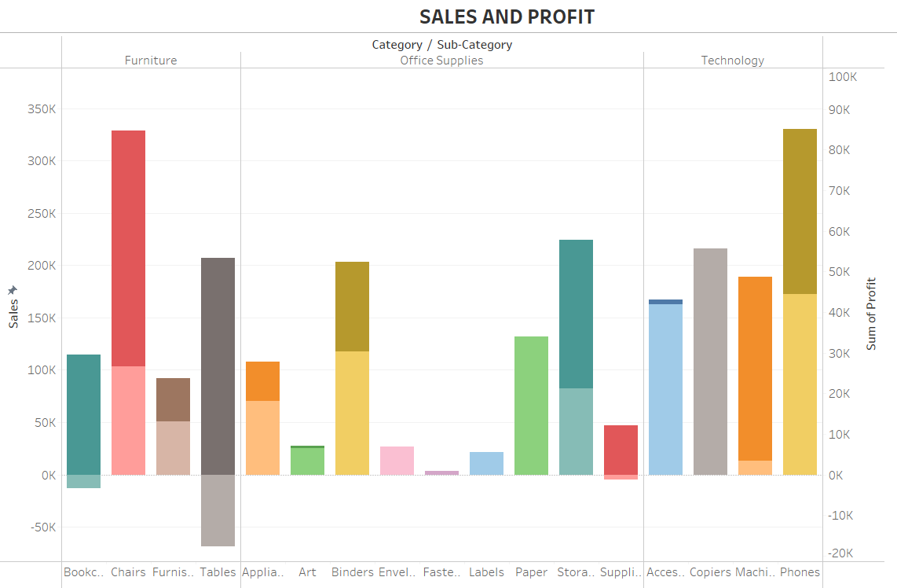

In this chart the dual axis helps us to show the sum of profit and sales of every category/sub category together. The lighter colour shows the SUM(PROFIT) margin of every category over their particular sales, while the entire bar shows the TOTAL SALES of the CATEGORY/SUB CATEGORY.

1. What is the distribution of order quantities for products in the dataset?

Answer

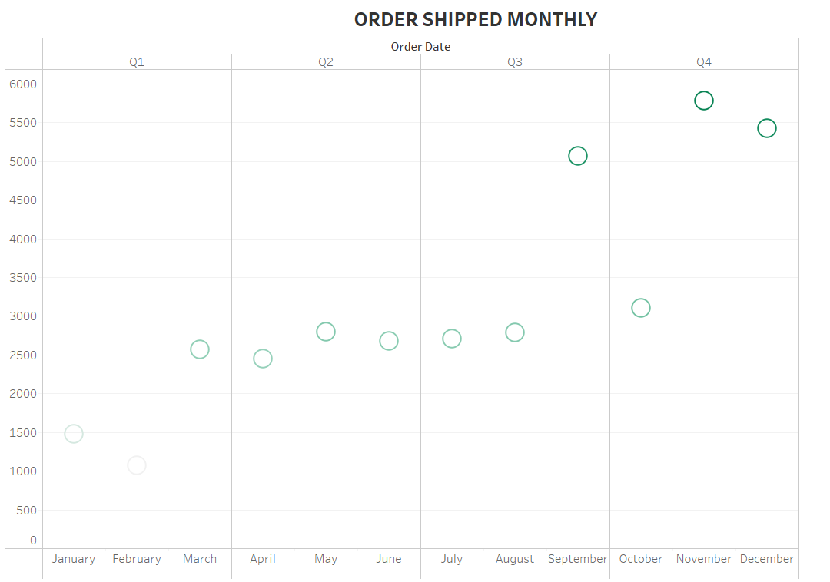 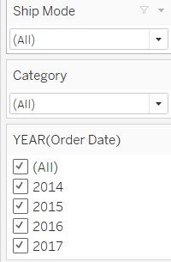

This chart shows the average distribution of order quantities for products in the dataset. This chart helps us to visualise the max distribution of order quantities has been placed in 4th quarter of the year.

The given filters can help us to analyse and visualise data based on the Shipping mode, Category and Year.

13.How do the profit distributions vary across different product categories?

Answer

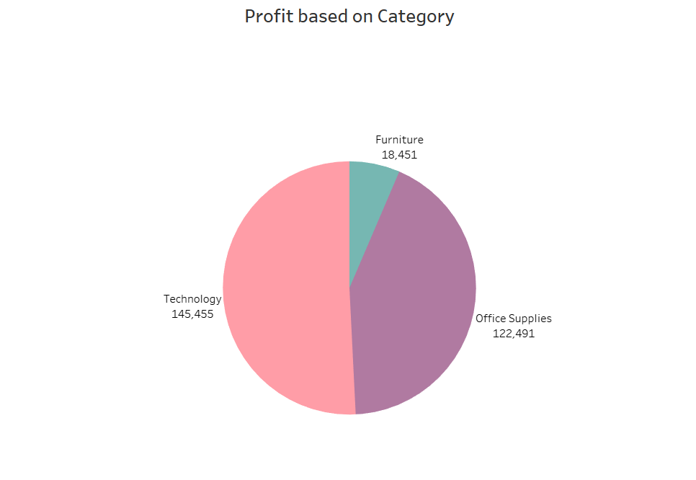

From the given chart we can easily visualize the profit distributions across different product categories.

Technology: 145,455

Office supplies: 122,491

Furniture: 18451

1. Can we compare the shipping time distributions for different shipping modes?
2. What is the monthly trend in the number of orders shipped?

Answer

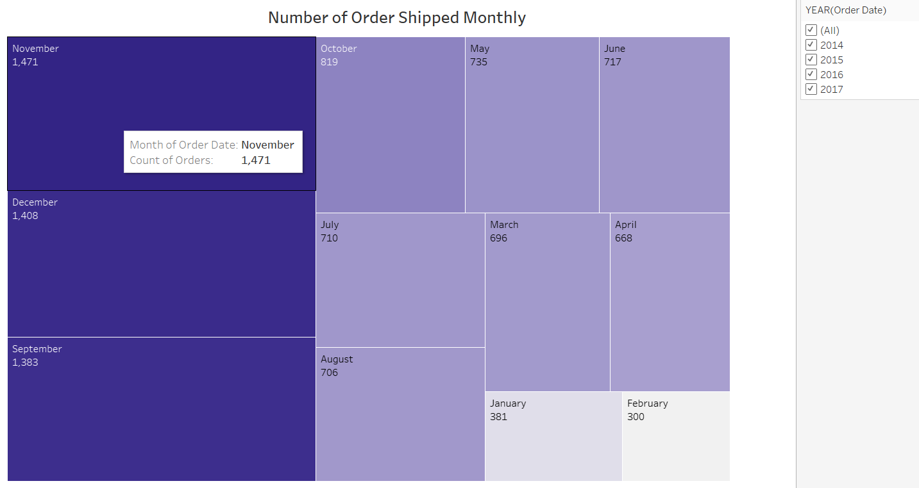

From the above chart and with the help of filter we can easily visualise the highest and lowest order shipped month:

|  |  |  |
| --- | --- | --- |
| YEAR | HIGHEST ORDER (MONTH) | LOWEST ORDER(MONTH) |
| 2014 | November [318] | February [46] |
| 2015 | November [324] | January [58] |
| 2016 | November [370] | February [83] |
| 2017 | December [462] | February [107] |

1. How do different customer segments perform in terms of sales and discount rates?

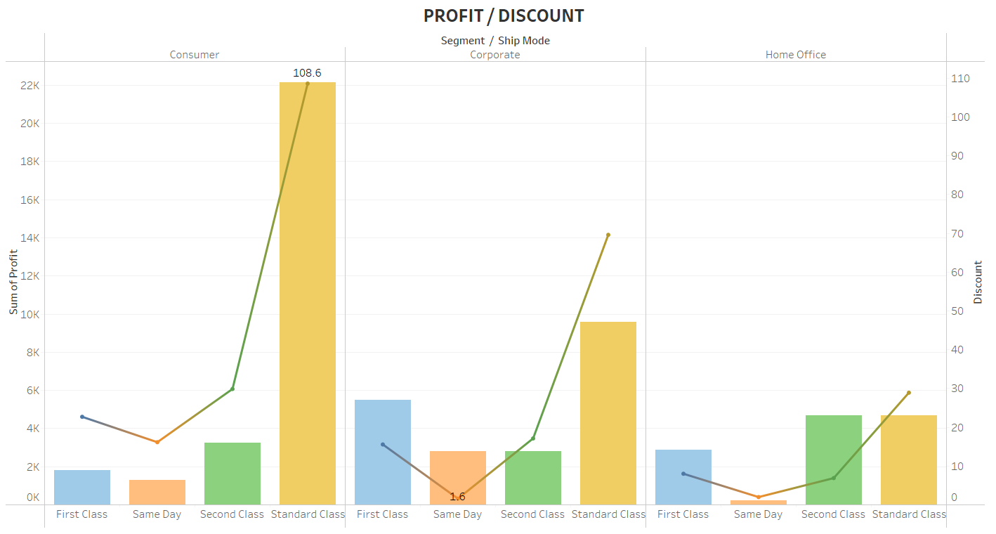

1. What are the sales and profit trends across different product subcategories and regions in the Superstore dataset?

Answer:

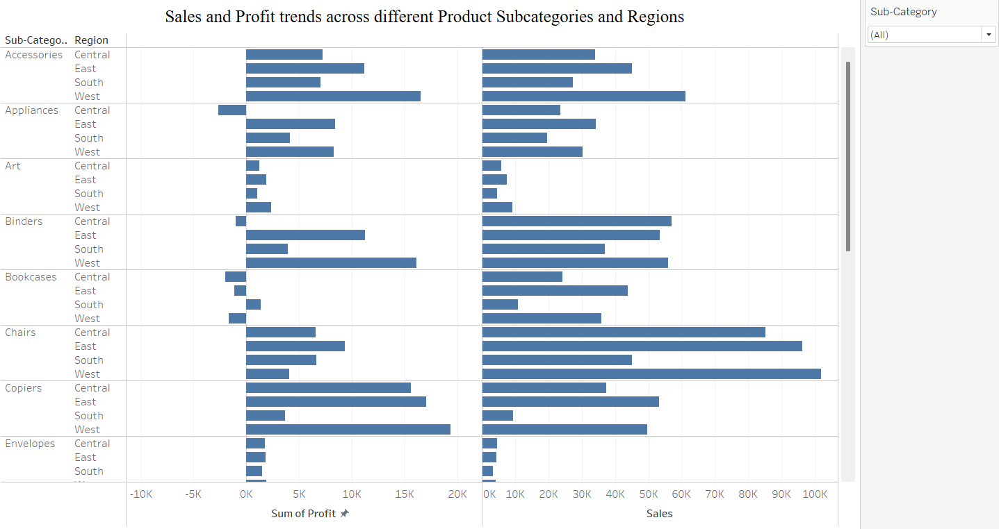

1. What is the average delivery duration for different regions and ship modes?Answer:
2. How has the average order quantity changed over the years for various product categories?

Answer:

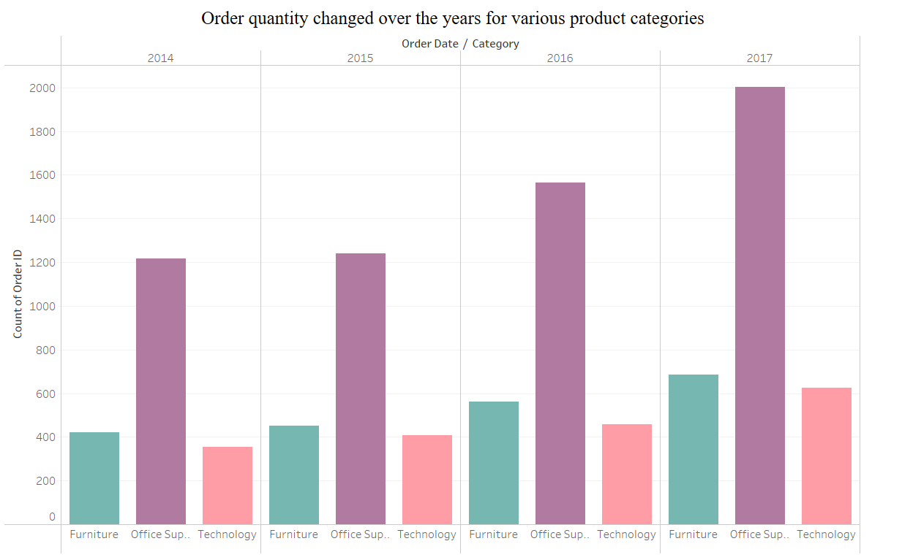

1. Can we visualise the correlation between discount rates and order quantities for different customer segments?

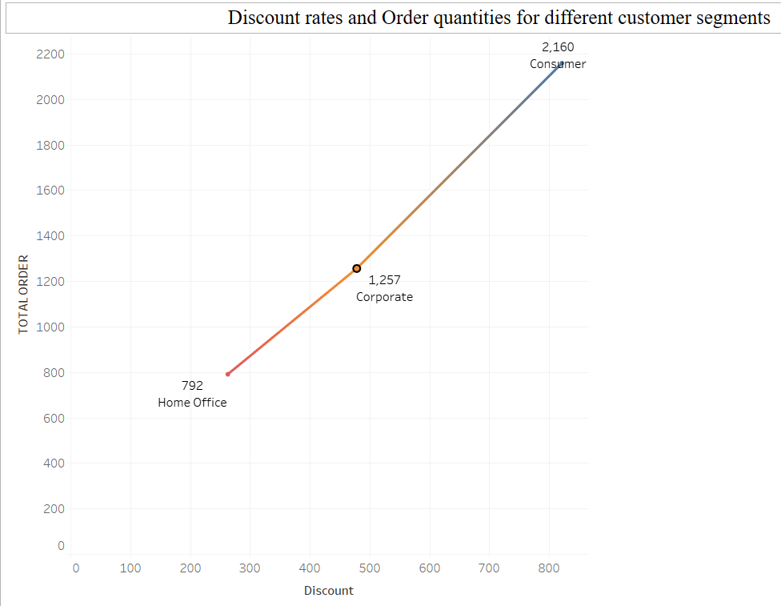

1. What is the proportion of orders returned in each region within the Superstore dataset?

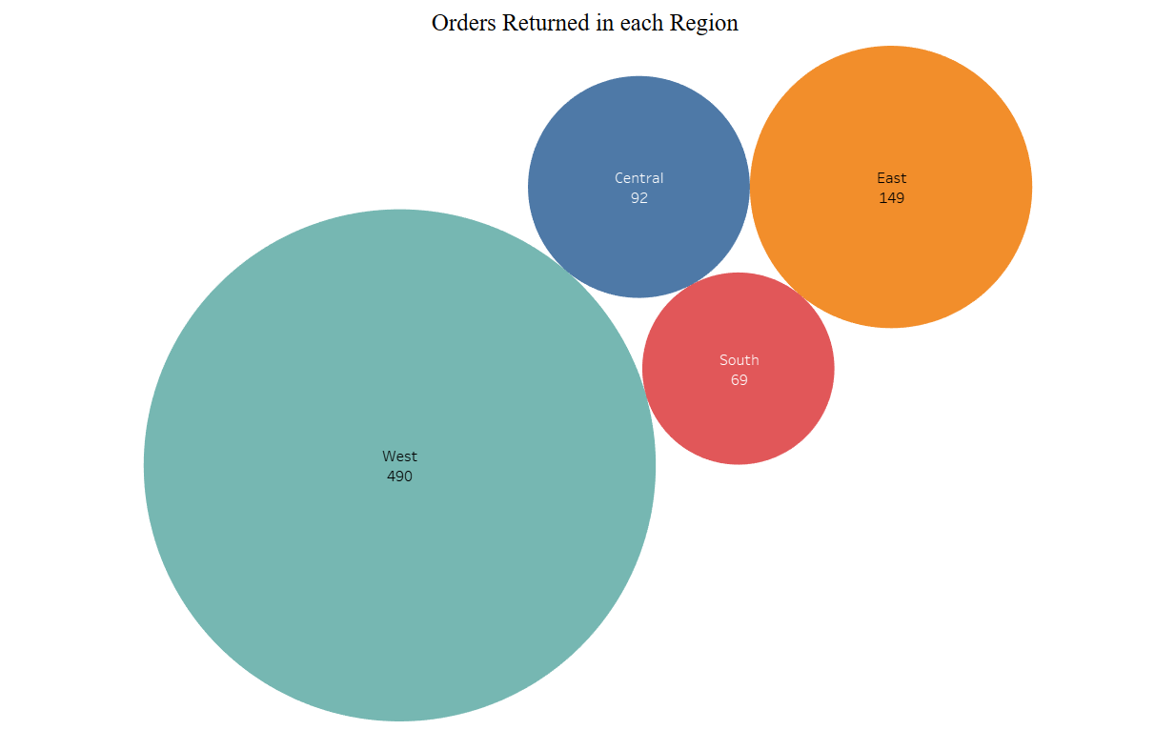

1. Can you compare the profit of different products for different subcategories?

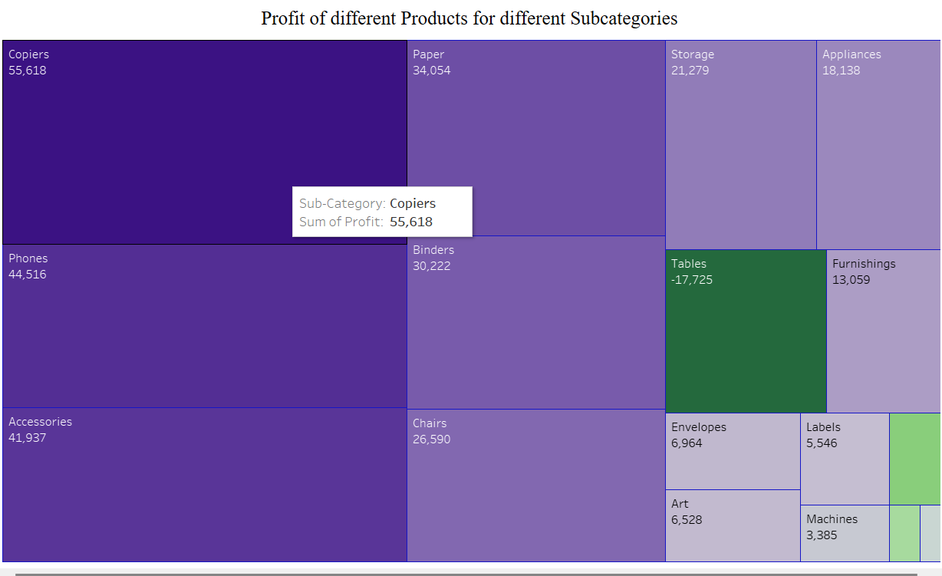

1. Which shipping mode is the most commonly used in the Sample Superstore dataset?

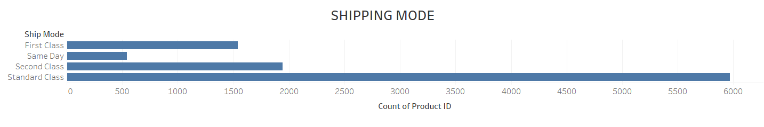

1. How does the sales performance of different regions evolve throughout the quarters of a year?

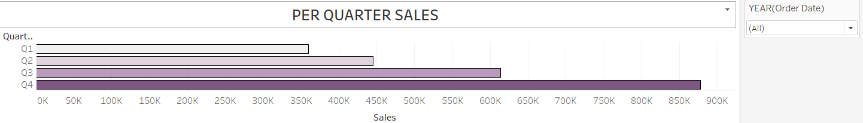

1. What is the distribution of order priorities across different product categories?

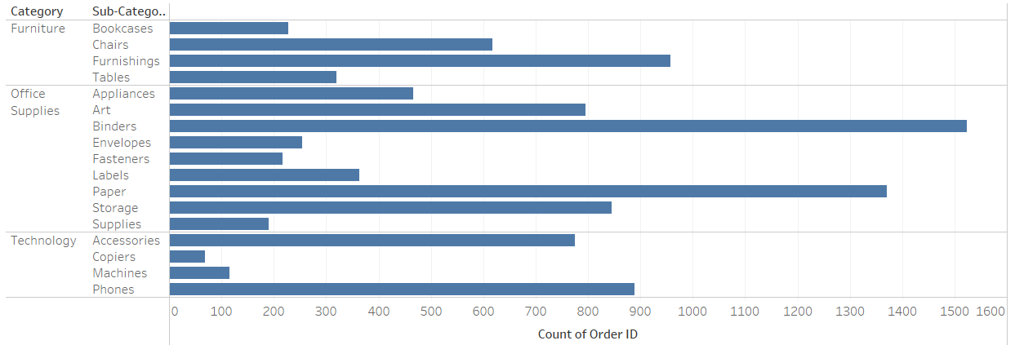

1. What is the relationship between discounts and sales?

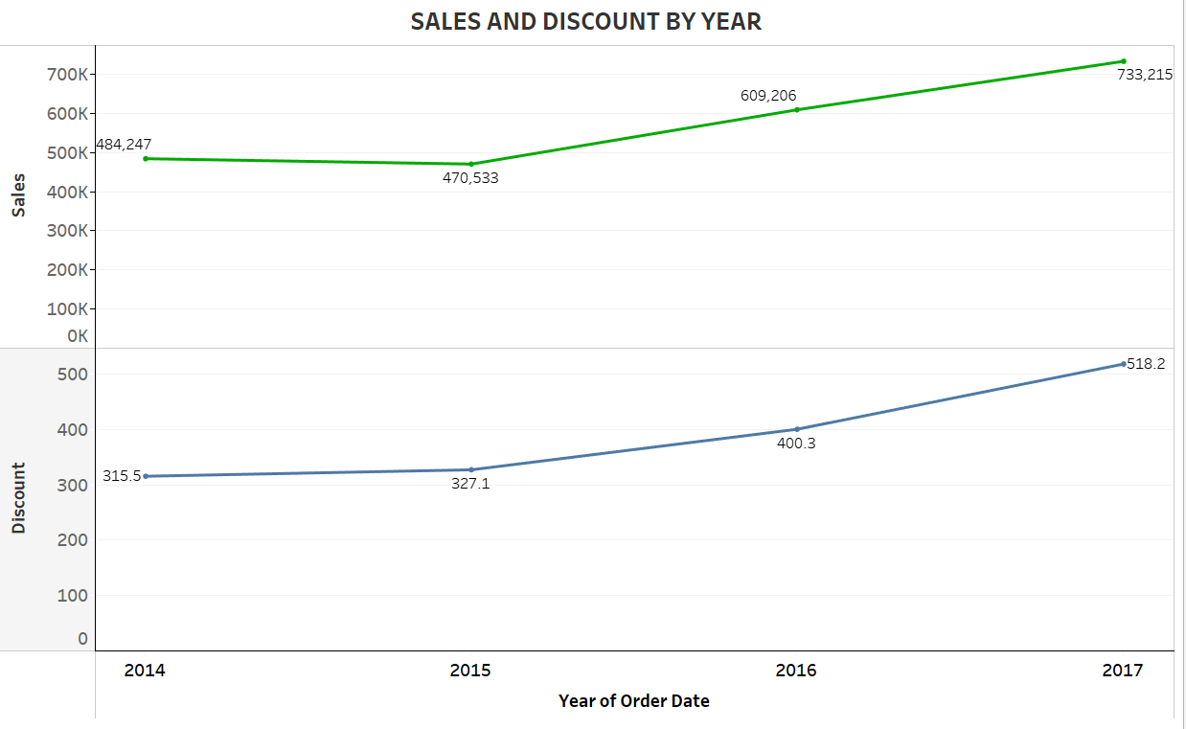

1. How does the average order value differ between repeat customers and new customers?

1. What is the geographical distribution of returns and its impact on overall profitability?

